

Undergraduate Lab Report

Course Title: Experiment of Computer Organization
Course No: 60080014
Student Name: 蒋云翔
Student No: 2022102330
School: 暨南大学
Department: 国际学院
Major: CST
Instructor： SUN Heng

Academic Year:2023 ~2024,Semester : 1st [ √ ] 2nd[ ]

Academic Affairs Office of Jinan University
Date (dd/mm/yyyy)__12/12/2023_____
Computer Organization Lab List
Student Name: 蒋云翔 Student No: 2022102330

ID | Lab Name | Type
1 | Number Storage Lab | Individual
2 | Manipulating Bits | Individual
3 | Simulating Y86-64 Program | Individual
4 | Performance Lab | Team
5 | A Simple Real-life Control System | Team
6 | System I/O | Individual
Undergraduate Lab Report of Jinan University
Course Title Experiment of Computer Organization Evaluation
Lab Name System I/O Instructor Sun Heng
Lab Address 116
Student Name 蒋云翔 Student No 2022102330
College 国际学院
Department Major CST
Date 12 / 12 / 2023 Morning / Afternoon
- Introduction
You have implemented Input/Output interfaces between mechanical and computational worlds in Lab 5. Further, this is a system robust I/O lab from the section 10.5 in textbook. The purpose of this lab is to become more familiar with the Unix-I/O.
- Lab Instructions or Steps
You are provided with the C programs. These codes are available from the lab materials. Related concepts can be found in the file 07.ppt of our theoretical course.
Activities to do-
a) Modify the cpfile program so that it uses the Rio unbuffered functions Rio_readn and Rio_writen to copy standard input to standard output, 10 bytes at a time. Use $ make to compile, and then use $ ./main.out to run. Remember to use & make again after modifying cpfile.c;
b) Modify the original cpfile program so that it takes an optional command line argument infile, such as: $ ./main.out infile.txt; If infile is given, then copy infile to standard output; otherwise, copy standard input (STDIN_FILENO) to standard output as before. The twist is that your program must use the original copy loop (lines 13–15) for both cases. You are only allowed to insert code, and you are not allowed to change any of the existing code.
- Lab Device or Environment
Computer: ASUS天选3 NVIDIA3060 i7
Virtual computer: VMware pro station 17.0 Ubuntu 16.04
- Results and Analysis
Situation 1: The entered bytes are less than 10
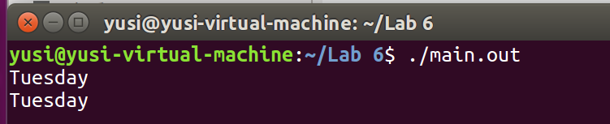
Situation 2: The number of bytes entered is greater than 10
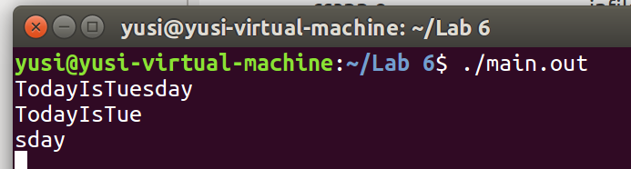
Situation 3: The specified input file does not exist
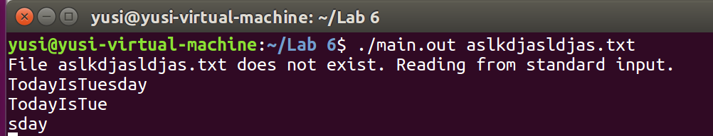

Situation 4: Specifies that the input file exists
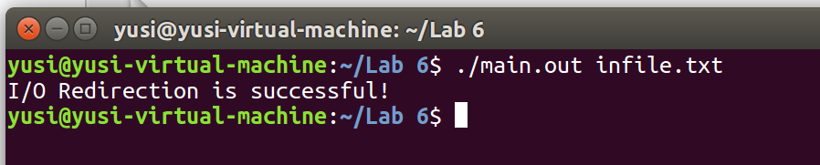
- Appendix (Program Code)
/* All of rio function implementations are obtained from csapp.c */
/* Please note the usage of wrapper function */

/* $begin cpfile */

#include "csapp.h"

int main(int argc, char** argv)

{
int n;
rio_t rio;
char buf[MAXLINE];
int fd;

/* Check that the input file is specified */
if (argc == 2) {
/* If an input file is specified, an attempt is made to open it */
if (access(argv[1], F_OK) != -1) {
fd = Open(argv[1], O_RDONLY, 0);
Rio_readinitb(&rio, fd);
while ((n = Rio_readlineb(&rio, buf, MAXLINE)) != 0)
Rio_writen(STDOUT_FILENO, buf, n);
}

else {
/* If the file does not exist, a message is displayed */
fprintf(stderr, "File %s does not exist. Reading from standard input.\n", argv[1]);
Rio_readinitb(&rio, STDIN_FILENO);
}
}
else {
/* No input file is specified and the standard input is read directly */ //Satisfy the requirement！！
Rio_readinitb(&rio, STDIN_FILENO);
}
/* Each character is read in turn and printed to standard output */
int count = 0;
while ((n = Rio_readnb(&rio, buf, 1)) != 0) {
if (buf[0] == '\n') {
continue; // Skip newline characters
}
Rio_writen(STDOUT_FILENO, buf, n);
count++;
if (count == 10) {
/* Line feed every 10 characters read */
Rio_writen(STDOUT_FILENO, "\n", 1);
count = 0;
}
}
/* If there is less than 10 characters left, output directly */
if (count > 0) {
Rio_writen(STDOUT_FILENO, "\n", 1);
}
exit(0);
}
/* $end cpfile */

